

Project Name: Retailer Inventory Management System

Branch E-DAC SEP-2020

Documentation On

**“**Retailer Inventory Management System**”**

E-DAC SEP 2020

**Guided By: Bakul Joshi**

Submitted By :

**Group No: 02**

* **Awdhesh Prajapati 200943081012**
* **Akshay Gautam bhujang 200943081004**
* **Gajendra Satish Pawane 200943081026**
* **Shubham Anil Borse 200943081016**

**Table of Contents**

**1. Introduction 4**

1.1 Document Purpose **4**

1.2 Project Background **4**

1.4 Aim & Objectives **4**

**2. Business Requirements Overview**…………………………………………………………**5**

**3.Functional Requirements** **6**

3.1 Retailer Module **6**

3.2 Wholesaler Module **6**

3.3 Admin Module **6**

4. **Non-Functional Requirement………………………………………………………………7**

**5. Use Case Diagram 8**

5.1 Admin **9**

5.2 Retailer **10**

5.3 Wholesaler **11**

**6. Database Design 12**

6.1 Retailer **12**

6.2 Wholesaler **13**

6.3 Admin……………………………………………………………………………**…….13**

6.3 User ……………………………………………………………………………**…….14**

6.3 Product……………………………………………………………………………**…….14**

6.3 Purchase or……………………………………………………………………………**…….15**

6.3 Purchase……………………………………………………………………………**…….15**

6.3 Reorder……………………………………………………………………………**…….16**

6.3 Stock……………………………………………………………………………**…….16**

6.3 Category……………………………………………………………………………**…….17**

6.3 Company……………………………………………………………………………**…….17**

**7. E-R Diagram………………………………………………………………………………………18**

**8. Snapshots 19**

**7. Conclusion 20**

**List of Figures**

**Use Case Diagrams 17**

Fig 1 Admin 8

Fig 2 Retailer 9

Fig 3 Wholesaler 10

Fig 4 ER Diagram 14

1. **Introduction:**
   1. **Document Purpose:**

This document explains the system requirements and scope for developing

Retailer Inventory Management System. Inventory management is the backbone

of any business operations. Every organization constantly strives to

maintain optimum inventory to be able to meet its requirements and avoid over or under

inventory that can impact the financial figures.

## Project Background:

Retailer Inventory Management System could divide the Three main parts, Retailer

part, Wholesaler part, Admin part.

.

## Aim & Objectives:

Application use to maintain all the information Retailer Inventory Management System. Retailer can view the product of required online. Save time of managing all the tasks for searching product. Reduce the time consumption required for visiting different places. Inventory is always dynamic. Inventory management requires constant and careful evaluation of external and internal factors and control through planning and review.

1. **Business Requirements Overview:**

* Retailer Inventory Management System is the public web application.
* Retailer Inventory Management System will be available globally.
* There are mainly three types of user. Admin, Retailer, And Wholesaler the Admin which manages the system.
* Admin can add/edit/delete product.
* Retailer can add/edit/delete product own access.
* Inventory management grows more and more complicated with increase in sales volume.
* Retailer Inventory Management System can be maintained by Administrator.

# Functional Requirements Overview:

The Account part of Retailer Inventory Management system has three modules.

* + - Retailer Module
    - Wholesaler Module
    - Admin Module

## Retailer Module:

* + - Retailer can create his account and request for registration.

Retailer can add or delete Whole sellers.

Retailer can update the stock Information.

On the basis Products availability, Retailers can purchase from the Whole seller

Retailers can generate detailed inventory reports about Products.

## Wholesaler Module:

* + - Wholesaler can register his account.
    - Wholesaler can add/edit/delete his/her details.

When Wholesaler creates new account, the function demands following information

## Admin Module:

* + - Admin can approve or reject the request from Retailer and Wholesaler
    - Admin can activate or block accounts if required.

1. **Non-Functional Requirement:**

* The website should use professional design, look and feel and color scheme.
* The system should be designed in such a manner that user will be able to complete tasks in minimum number of steps.
* Being a public website, the site must follow general usability guidelines for menus, navigation, colors, links and other actions provided on the screens.
* Users will have no limitations for accessing the application through Internet. The portal being an internet application, it is difficult specify exact number of visitor or users. Hence we will target the system to support number of users.

## 5.Use-Case Diagram

**5.1 Admin:**

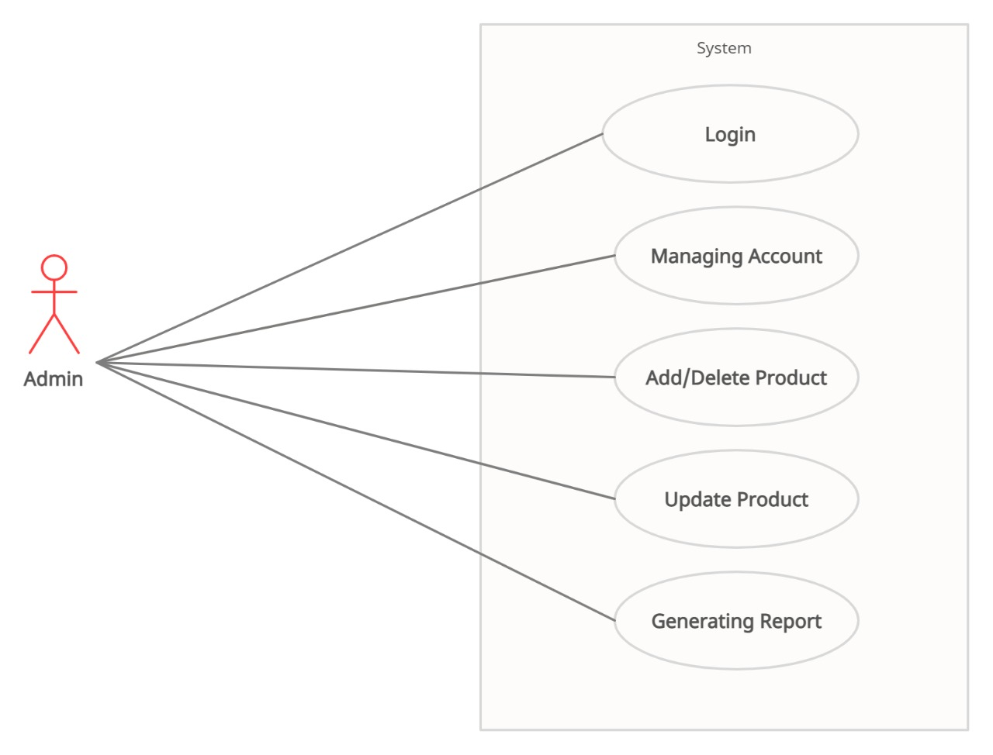

Fig. Use-Case Diagram for Admin

## 5.2 Retailer:

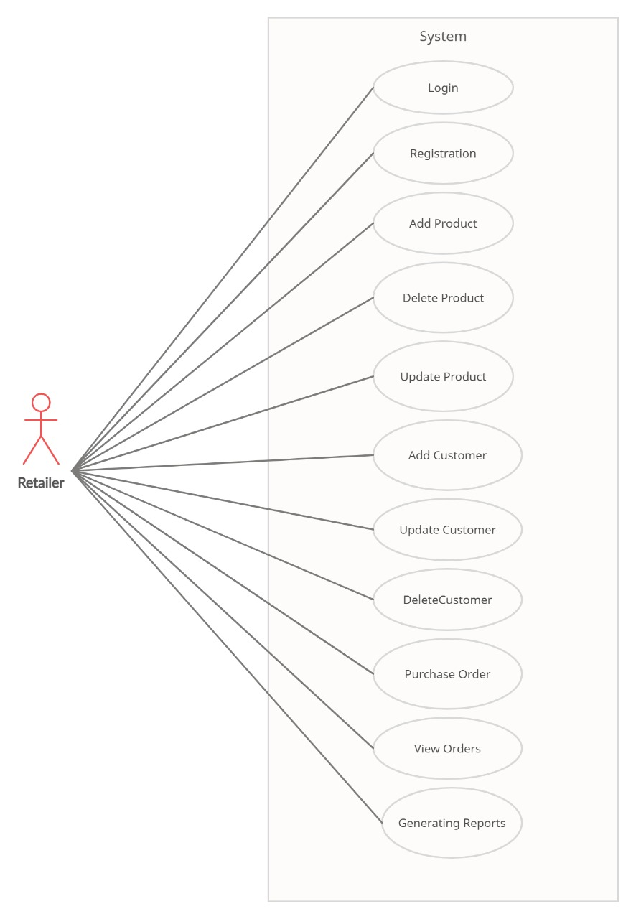

**5.3 Wholesaler:**

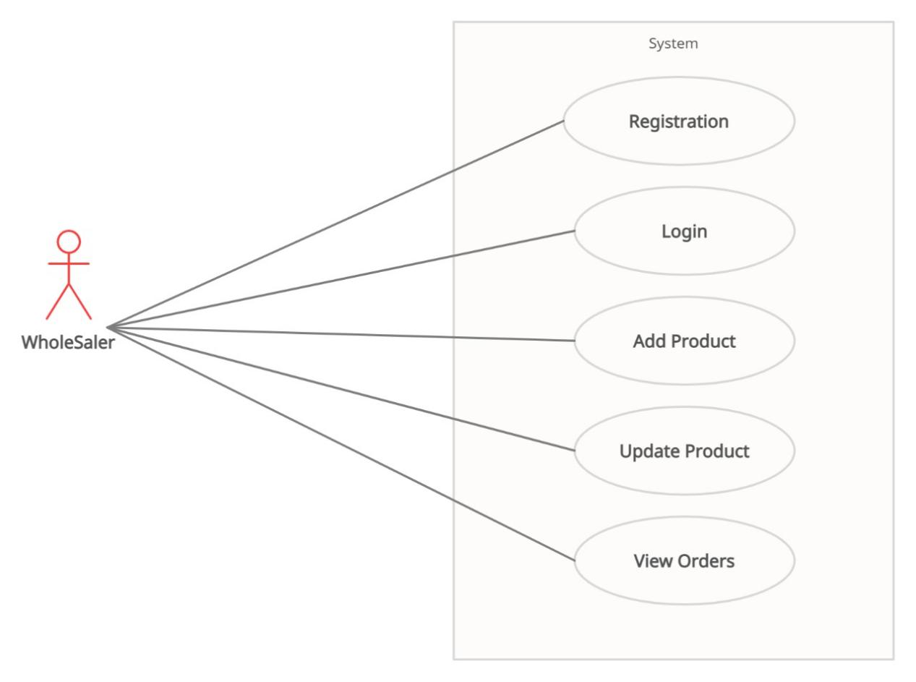

**6. Database Design:**

**1] Tbl_User**

|  |  |  |  |  |  |
| --- | --- | --- | --- | --- | --- |
| **Field** | **Type** | **Null** | **Key** | **Default** | **Description** |
| U_id | Integer | No | Primary key |  | User ID |
| Fname | Varchar(45) | No |  |  | First Name |
| Lname | Varchar(45) | No |  |  | Last Name |
| Email | Varchar(45) | No |  |  | Email ID Of Wholesaler |
| Password | Varchar(15) | No |  |  | Account Password |
| ContactNo | Integer | No |  |  | Contact No. Of Wholesaler |
| Address | Varchar(100) | No |  |  | Permanent Address |
| Gender | Varchar(10) | No |  |  | Gender Information |
| GST_no | Integer | Yes |  | Null | Gst no. Information |
| Business_name | Varchar(45) | Yes |  | Null | Business name Information |
| Type | varchar(15) | No |  |  |  |

**2] Tbl_Product**

|  |  |  |  |  |  |
| --- | --- | --- | --- | --- | --- |
| **Field** | **Type** | **Null** | **Key** | **Default** | **Description** |
| p_id | Integer | No | Primary key |  | Product ID |
| Pname | Varchar(45) | No |  |  | Product Name |
| Categoryid | Varchar(45) | No | Foreign key |  | From Category table |
| Price | Double | No |  |  | Product Price |
| Image | Blob | Yes |  | Null | Product Image |
| Unit | integer | No |  |  | Product Unit |
| Unit description | Varchar(45) | No |  |  | Unit Description |
| c_id | integer | No | Foreign key |  | cid from company table |

**3] Tbl_PurchaseOrder**

|  |  |  |  |  |  |
| --- | --- | --- | --- | --- | --- |
| **Field** | **Type** | **Null** | **Key** | **Default** | **Description** |
| po_no | Integer | No | Primary key |  | Product Number |
| U_id | Integer | No | Foreign key |  | User id from user Table |
| Date | Date | No |  |  | Date Information |
| Ship_Add | Varchar(45) | No |  | l | Shipping Address |

**4] Tbl_Purchase**

|  |  |  |  |  |  |
| --- | --- | --- | --- | --- | --- |
| **Field** | **Type** | **Null** | **Key** | **Default** | **Description** |
| po_no | Integer | No | Foreign key | Null | po_no and p_id are composite key |
| P_id | Integer | No | Foreign key | Null |
| Quantity | Double | No |  | Null | Product Quantity |

**5] Tbl_ReorderLevel**

|  |  |  |  |  |  |
| --- | --- | --- | --- | --- | --- |
| **Field** | **Type** | **Null** | **Key** | **Default** | **Description** |
| p_id | Integer | No | Primary key |  | Product ID |
| re_order | Integer | No |  |  | Reorder level |

**6] Tbl_Stock**

|  |  |  |  |  |  |
| --- | --- | --- | --- | --- | --- |
| **Field** | **Type** | **Null** | **Key** | **Default** | **Description** |
| s_id | Integer | No | Primary key |  | stock id |
| p_id | Integer | No | Foreign key |  | p_id from Product Table |
| edate | Date | No |  |  | Expiry Date |
| mdate | Date | No |  |  | Manufacturing Date |
| date | Date | No |  |  | Entry Date |
| qty | Integer | No |  |  | Quantity Information |
| price | Double | No |  |  | Price of Product |

**7] Tbl_Category**

|  |  |  |  |  |  |
| --- | --- | --- | --- | --- | --- |
| **Field** | **Type** | **Null** | **Key** | **Default** | **Description** |
| category_id | Integer | No | Primary key |  | Category Id |
| category_name | Varchar(45) | No |  |  | Category Name |

**8] Tbl_Company**

|  |  |  |  |  |  |
| --- | --- | --- | --- | --- | --- |
| **Field** | **Type** | **Null** | **Key** | **Default** | **Description** |
| c_id | Integer | No | Primary key |  | Company id |
| company_name | Varchar(45) | No |  |  | Company Name |

## 7. ER-Diagram:

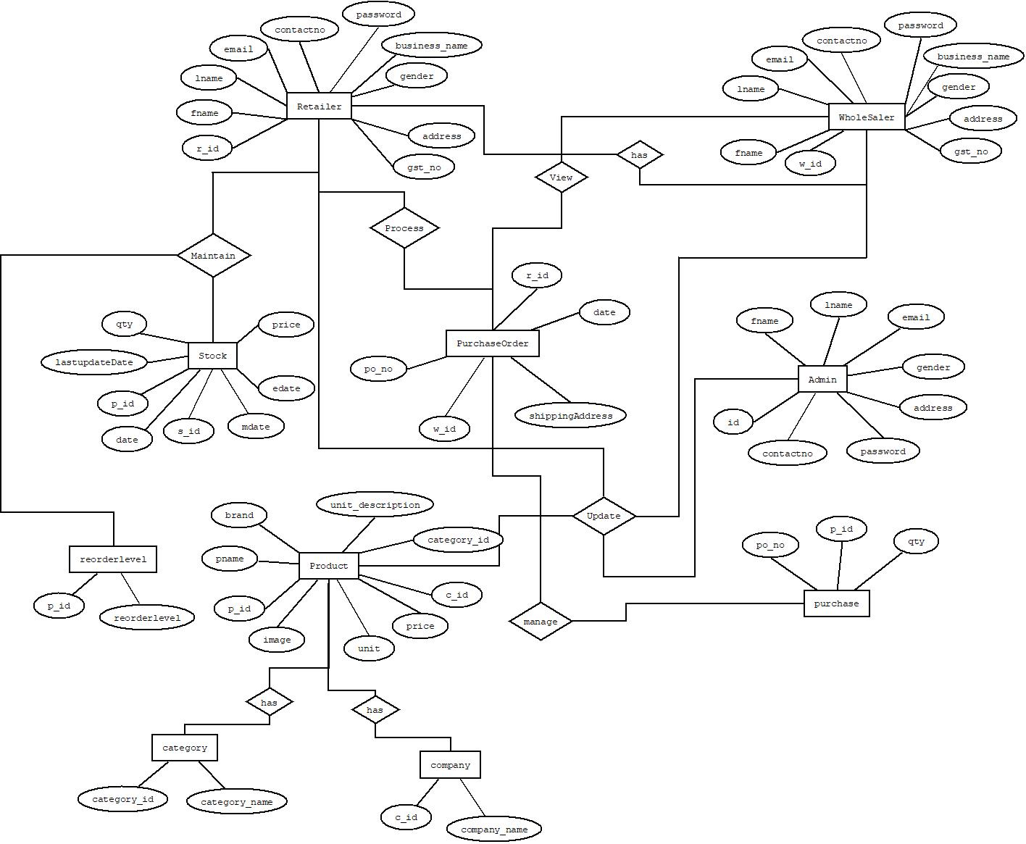

**E-R diagram shows database of Retailer Inventory Management System**

**8.Snapshots:**

**8.1 Home Page:**

Following snapshot shows the home page for **of** Retailer Inventory Management System

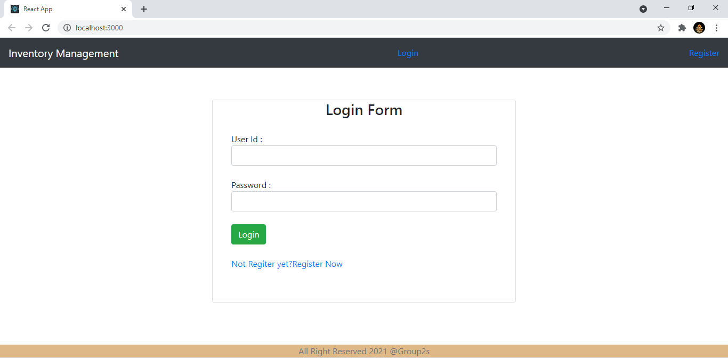

This page contains following controls

* Login Button
* Who Admin
* Home

## Login Button

when user fill the login user-id and password and click login button then if the information is valid then he will be redirected to respective home page , else error message will be shown to user.

## Registration link;

When user click on registration link then he will be redirect to registration page.

**8.2 User Registration**

Following snapshot shows the registration page for of Retailer Inventory Management System

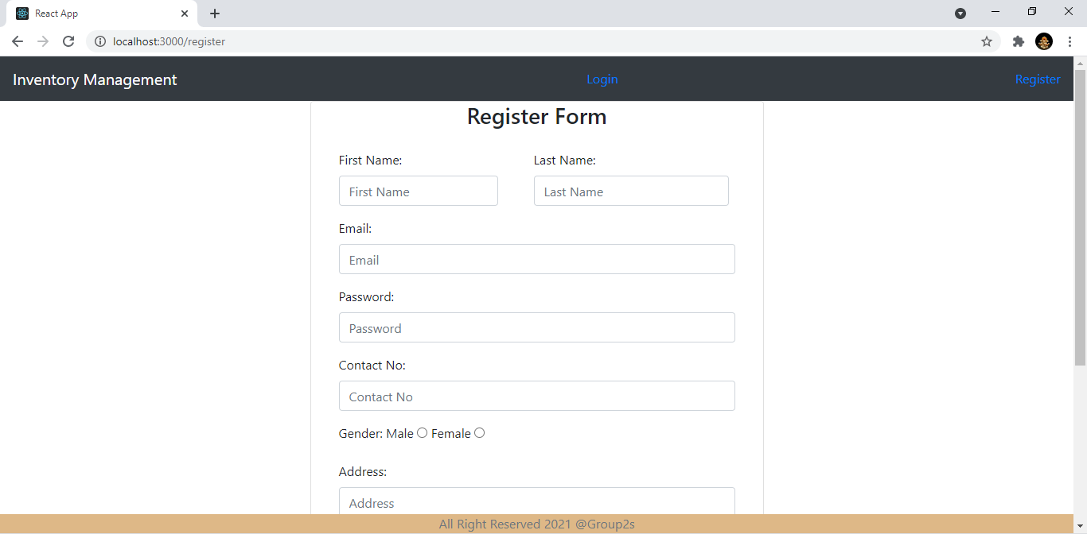

**8.4 Product List**

Following snapshot shows the Product List page for Inventory Management System

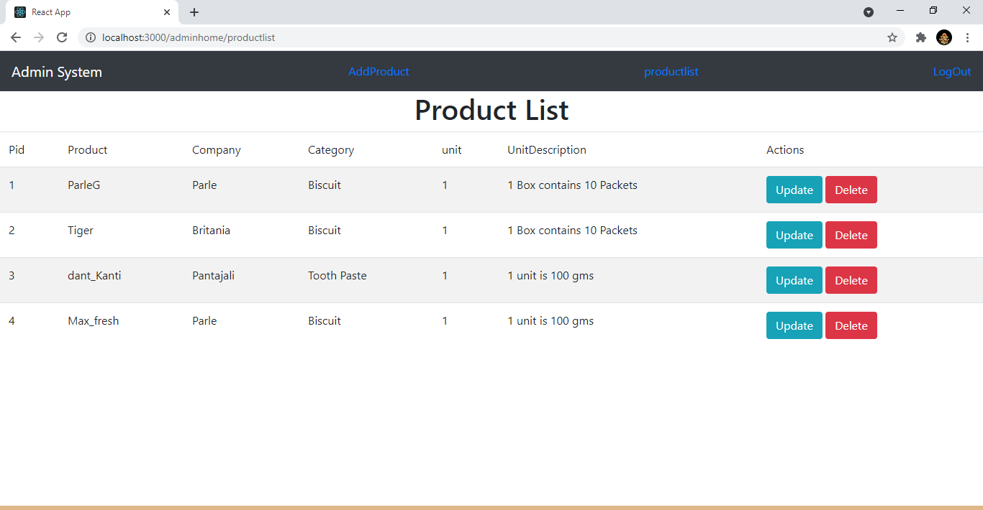

**8.5 Admin Add Product**

Following snapshot shows the Add Product page for Inventory Management System

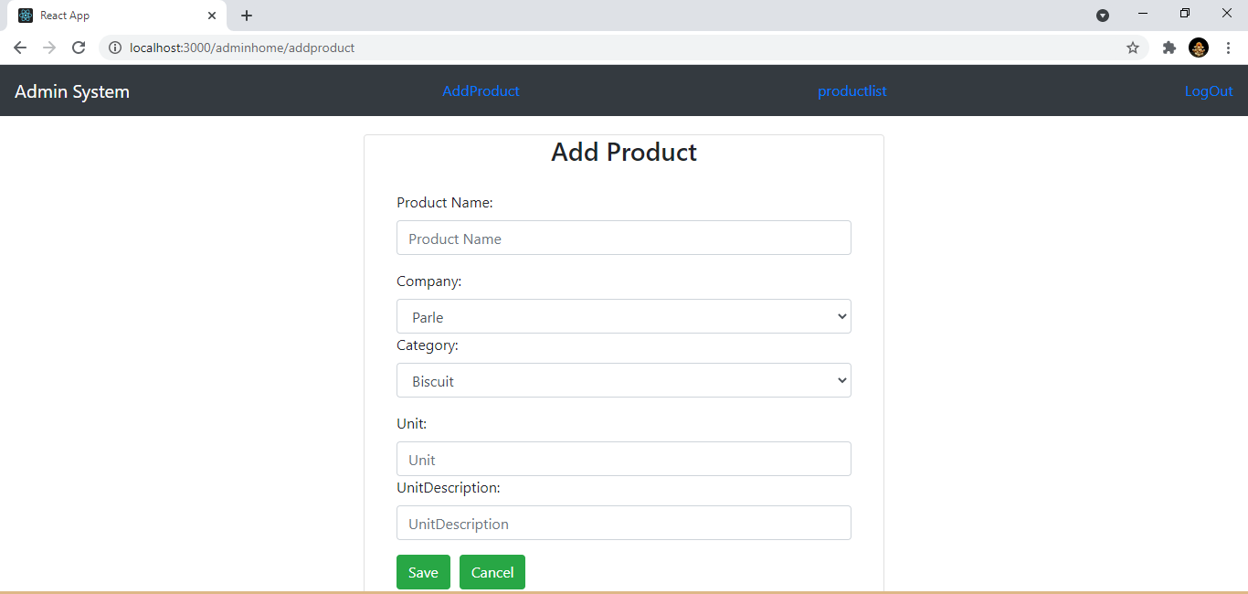

**8. Retailer Order list**

Following snapshot shows the order order List page for Inventory Management System

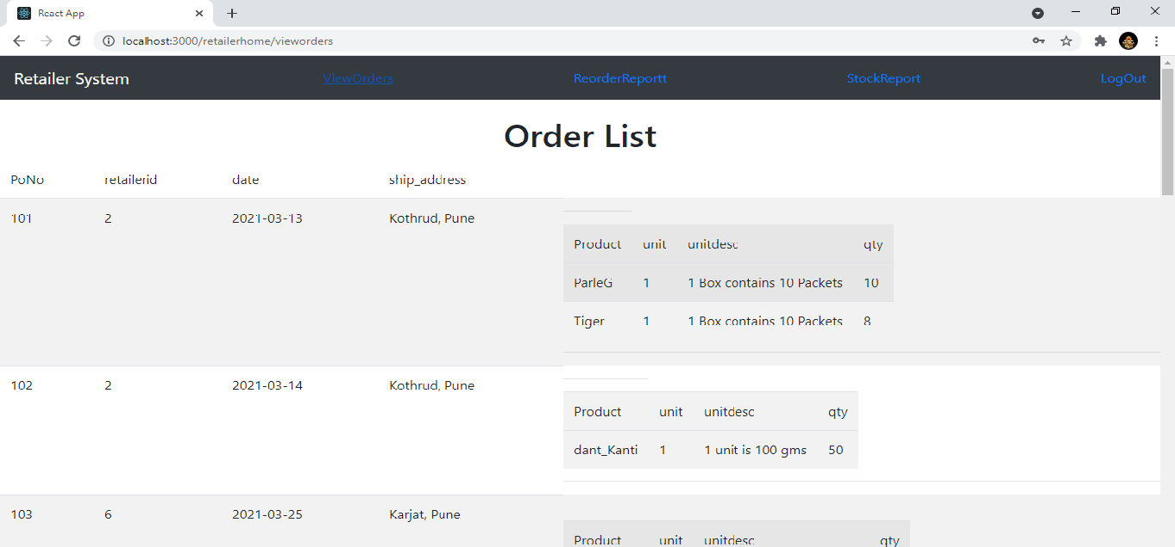

**8. Reorder List**

Following snapshot shows the reorder List page for Inventory Management System

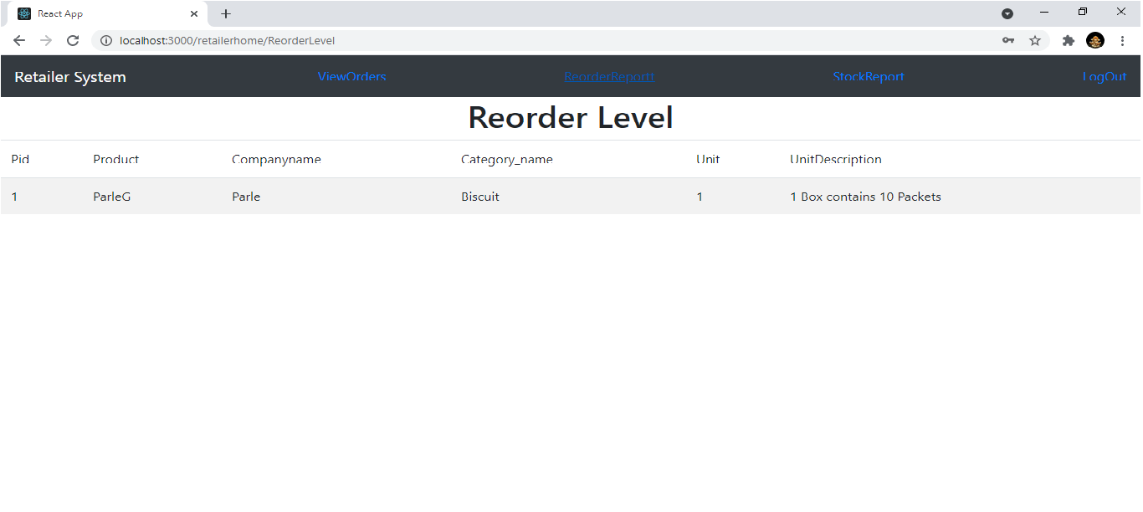

**8. Stock Report**

Following snapshot shows the Stock Report List page for Inventory Management System

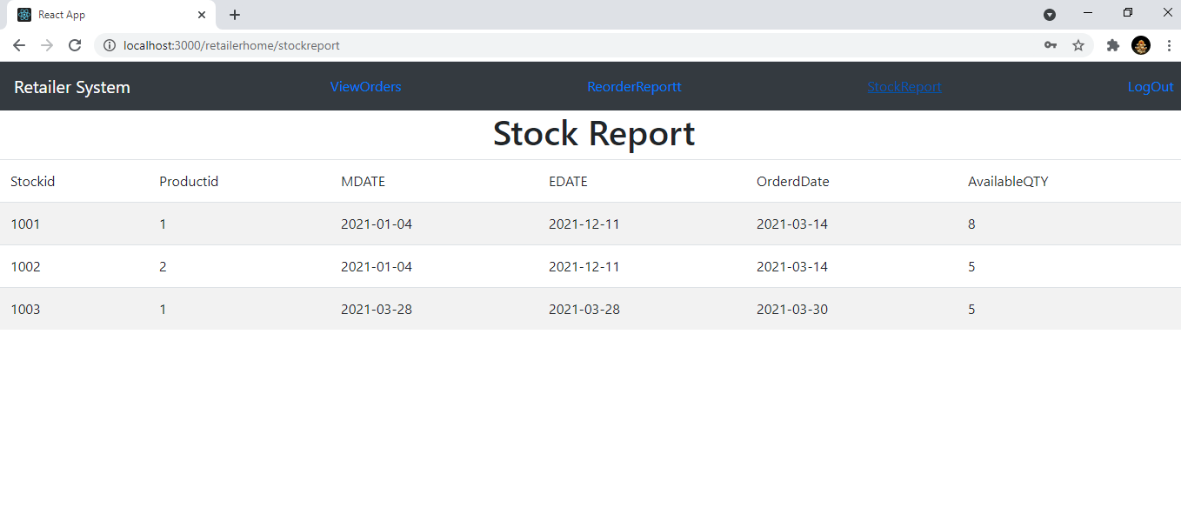

**8. Wholesaler**

Following snapshot shows the Wholesaler order Report List page for Inventory Management System

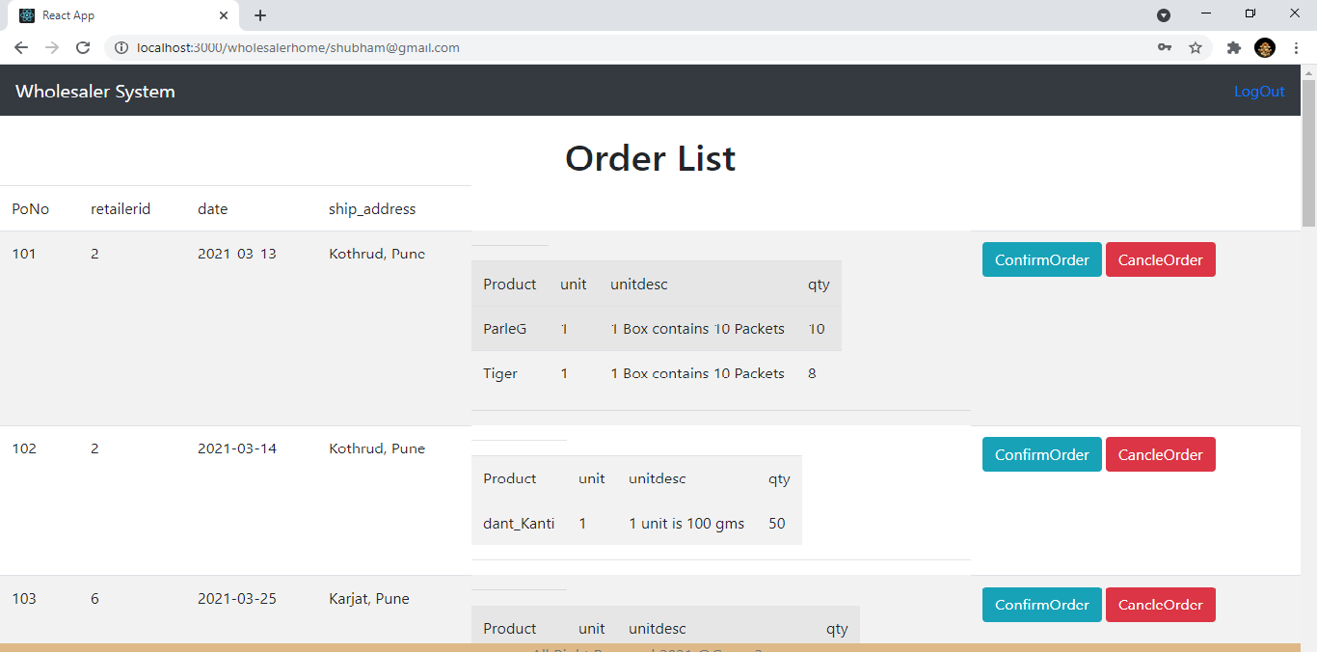

1. **CONCLUSION AND FUTURE SCOPE**

* Inventory Management System provides a platform to get connected with each other easily Inventory Management.
* Our System provides a very user-friendly platform registration system where user can easily create account and manage inventory system for business.